Peixin Yao(001526352)

**Program Structures & Algorithms**

**Fall 2021**

**Assignment No. 2**

* **Task (List down the tasks performed in the Assignment)**

Part1:You are to implement three methods of a class called *Timer*. Please see the skeleton class that I created in the repository. *Timer* is invoked from a class called *Benchmark_Timer* which implements the *Benchmark* interface. The APIs of these class are as follows:

Part2:Implement *InsertionSort*(in the *InsertionSort* class) by simply looking up the insertion code used by*Arrays.sort.* If you have the *instrument = true* setting in *test/resources/config.ini*, then you will need to use the *helper* methods for comparing and swapping (so that they properly count the number of swaps/compares). The easiest is to use the *helper.swapStableConditional* method, continuing if it returns true, otherwise breaking the loop. Alternatively, if you are not using instrumenting, then you can write (or copy) your own compare/swap code. Either way, you must run the unit tests in *InsertionSortTest*.

Part3: Implement a main program (or you could do it via your own unit tests) to actually run the following benchmarks: measure the running times of this sort, using four different initial array ordering situations: random, ordered, partially-ordered and reverse-ordered. I suggest that your arrays to be sorted are of type *Integer*. Use the doubling method for choosing *n*and test for at least five values of *n.*Draw any conclusions from your observations regarding the order of growth.

* **Relationship Conclusion: (For ex : z = a * b)**

When the length of the array doubles,Insert sort time increased by 4 times



* **Evidence to support the conclusion:**

1. **Output (Snapshot of Code output in the terminal)**

Part3:（INFO6205-Fall021\src\test\java\edu.neu.coe.info6205\until\insertionSortTimeTest）

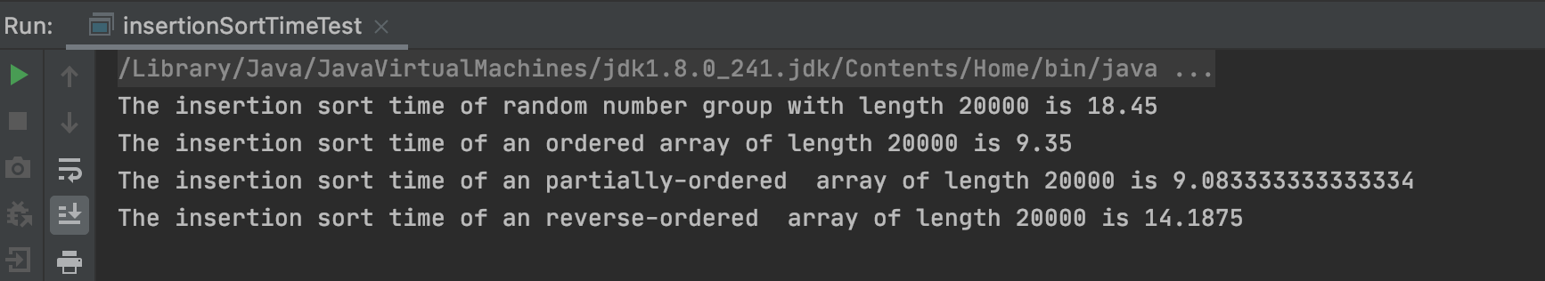

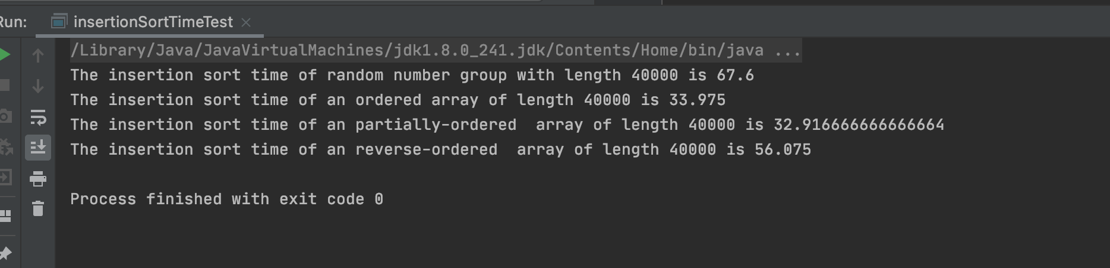

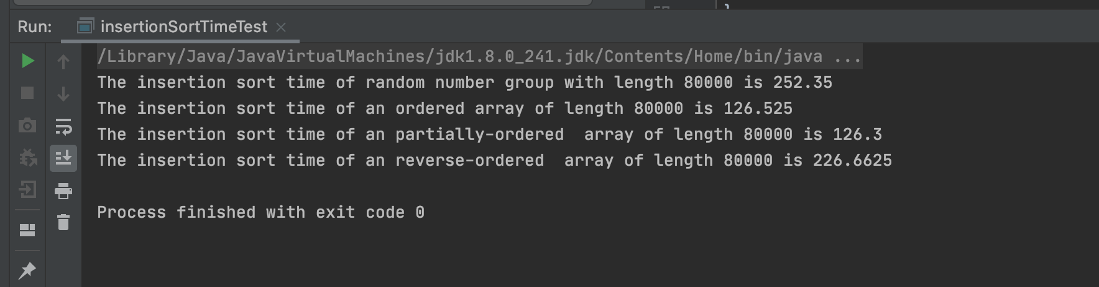

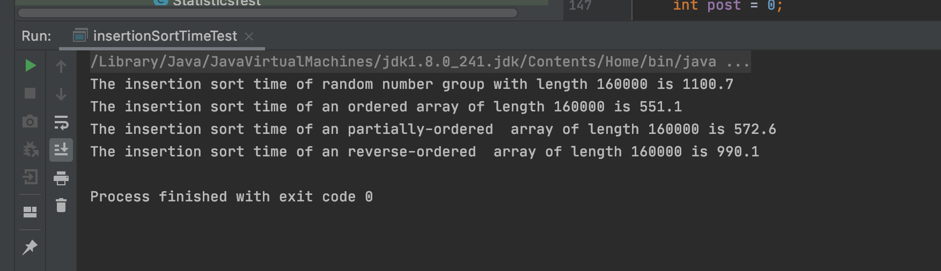

1. **Graphical Representation(Observations from experiments should be tabulated and analyzed by plotting graphs(usually in excel) to arrive on the relationship conclusion)**

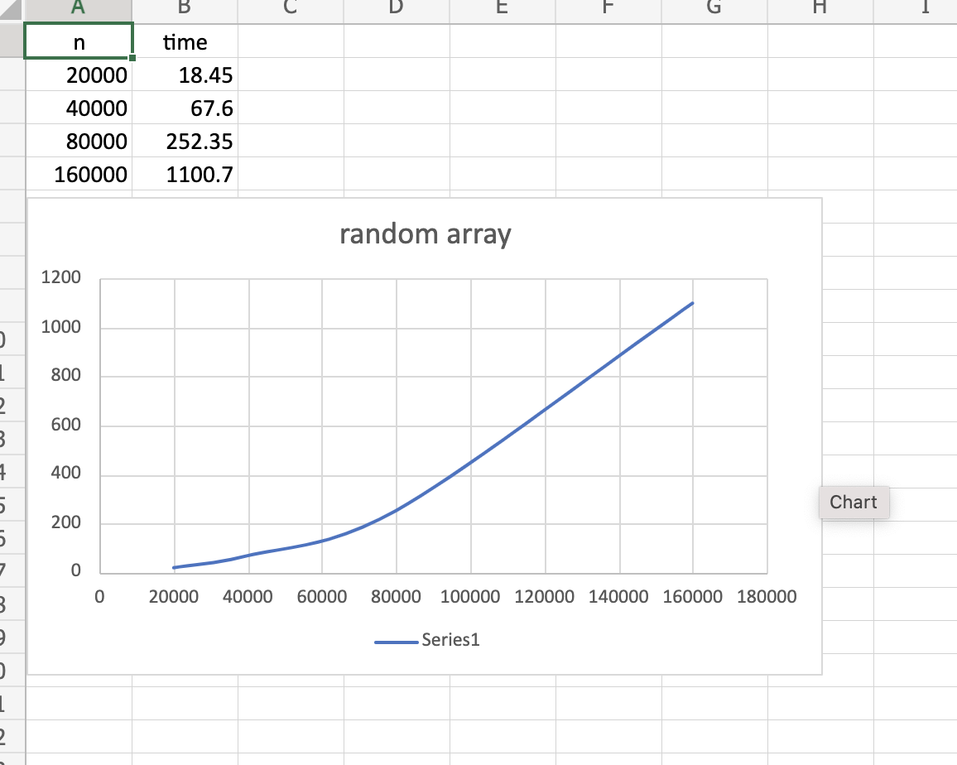

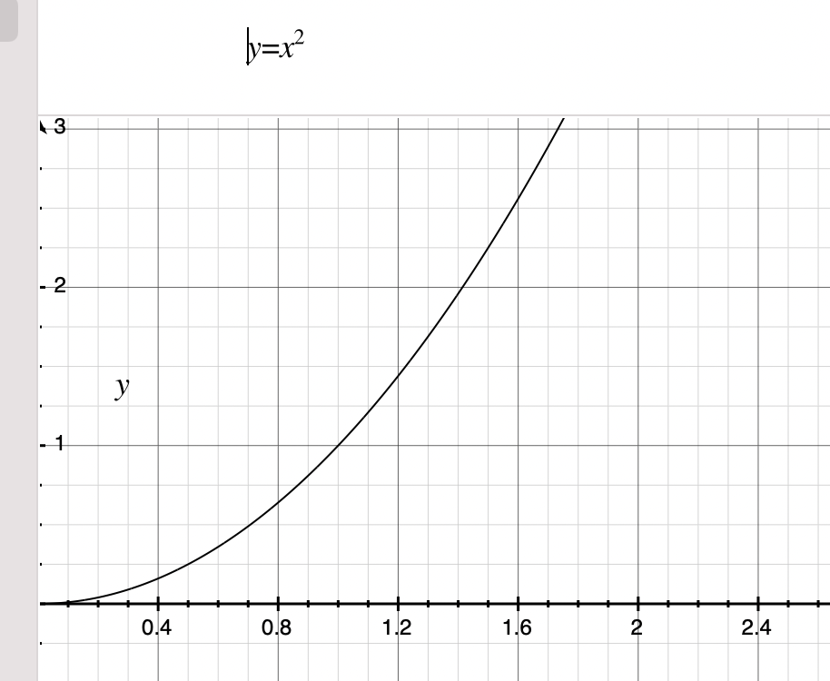

* **Unit tests result:(Snapshot of successful unit test run)**

Part1: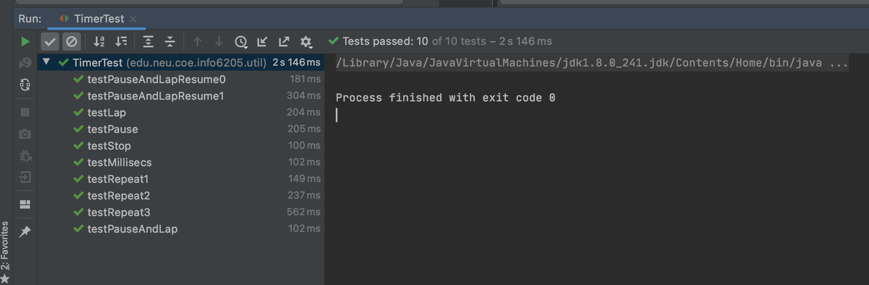

Part2:

